**What will we do?**

* Use Jupyter Notebook to write and run Python script.
* Use TextBlob methods to process text (tokenization, n-gram)
* Use the Counter() module to get pattern frequency
* Use Pandas dataframe and write dataframe to csv
* Use list comprehension and dictionary comprehension

**Why are we doing this?**

* Streamline the coding process
* Improve coding efficiency
* Simplify the code script and reduce errors
* Find easier and faster ways to checking results

**What do I need to do before the workshop?**

* Download and save the following files on your computer:

1. locness_new.txt
2. workshop.ipynb

These files are also available here: <https://github.com/zhichen-isu/Python-Code>

* Follow the instructions below to install JupyterLab and Textblob on your computer. But don’t worry if you failed to do so. Just make sure you have Python on your computer and pip is working. We can go over JupyterLab and TextBlob installation together in the workshop.

**JupyterLab Installation Instructions** 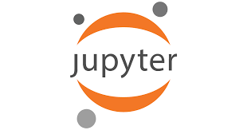

* At the terminal command prompt, type and run:

pip install jupyterlab

**TextBlob Installation Instructions** 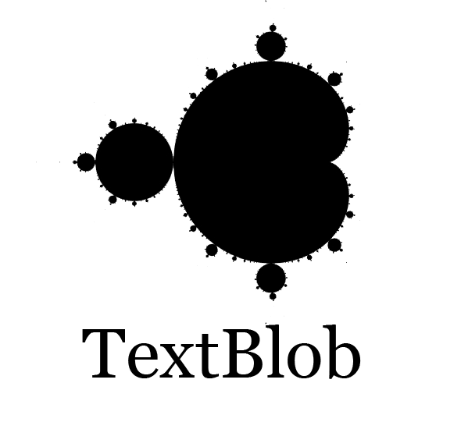

* At the command prompt, type and run:

pip install -U textblob

py -m textblob.download_corpora lite

**Run JupyterLab**

* Run Jupyterlab from the terminal by typing:

jupyter lab

Jupyterlab will appear in a browser. Please keep the terminal open (you can minimize it).

